|  |  |
| --- | --- |
| Course Name | ITD 2263 – Graphical User Interface Development |
| Instructor | Daniel D. Claborn |
| Student Name | Derrick McFall |
| Due date | Dec 10, 2017 11:59 PM |
| Grade | 95% |
| Grading Comments | Individual Feedback  missing header on report  program looks good |

2. 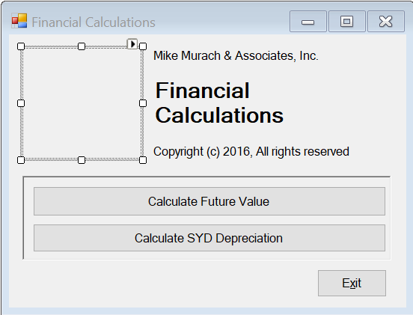

2b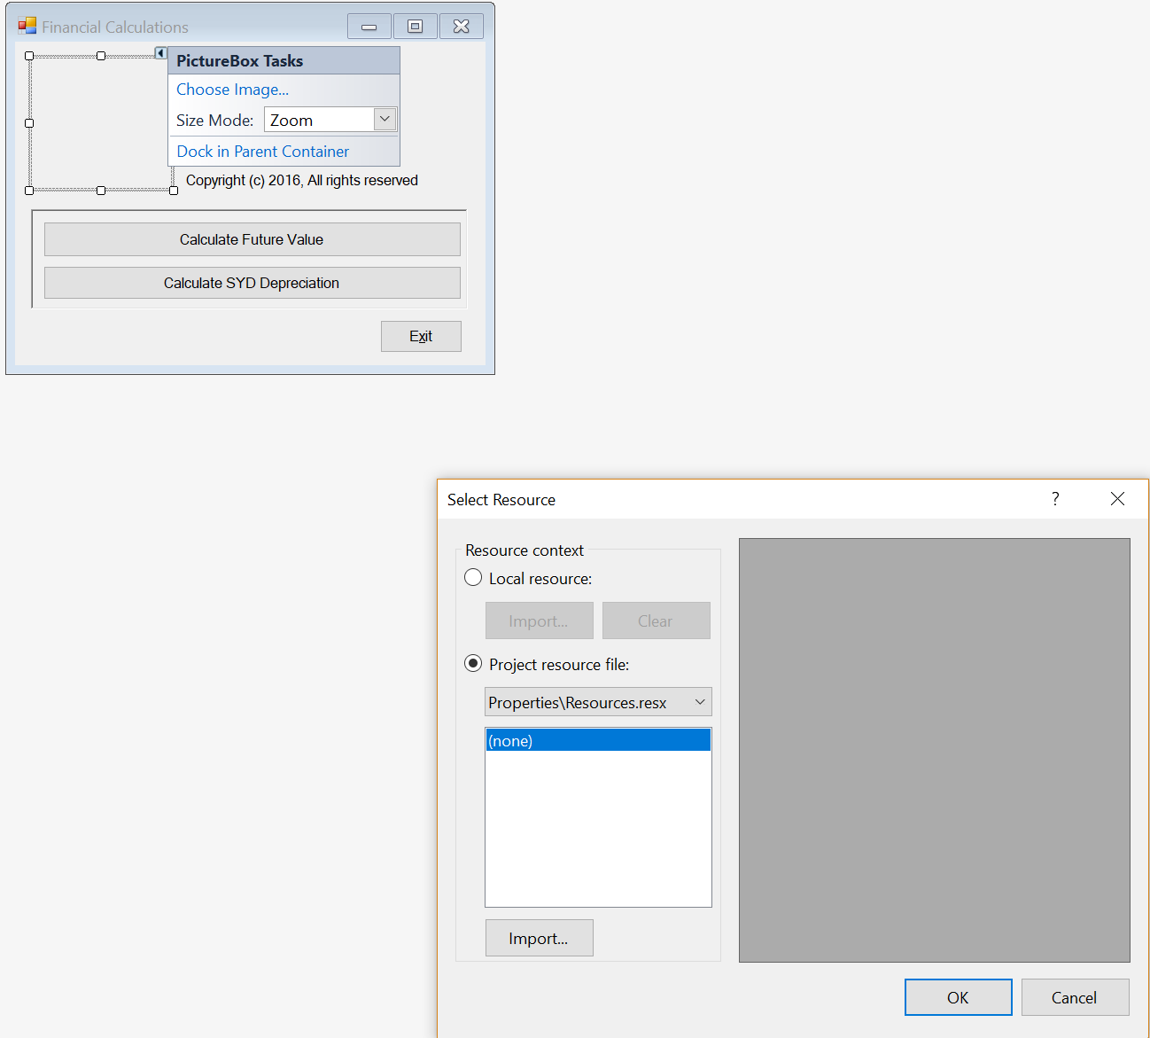

2c. 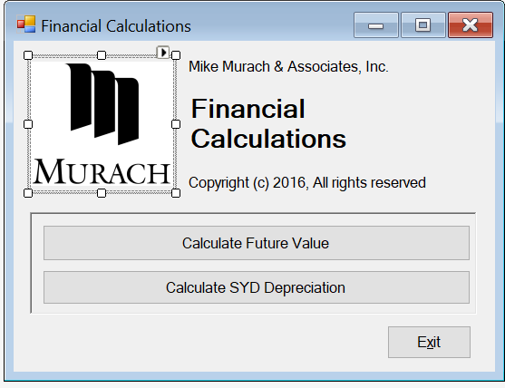

3. 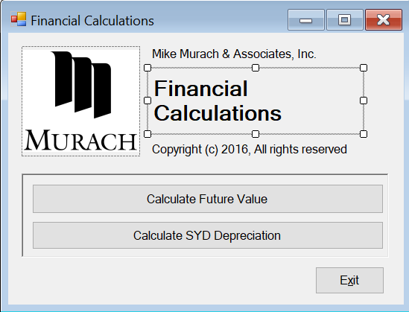

This is not a text box it is a label.

4. 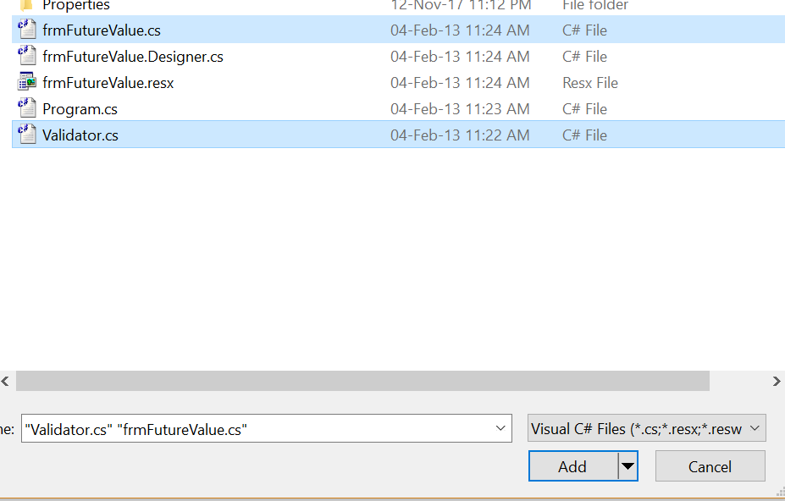

5.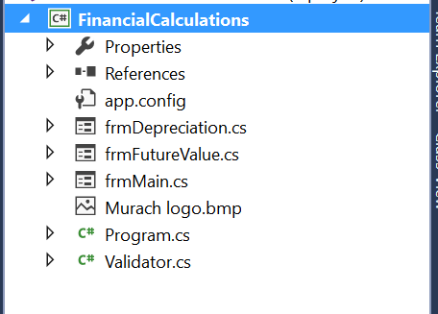

6. 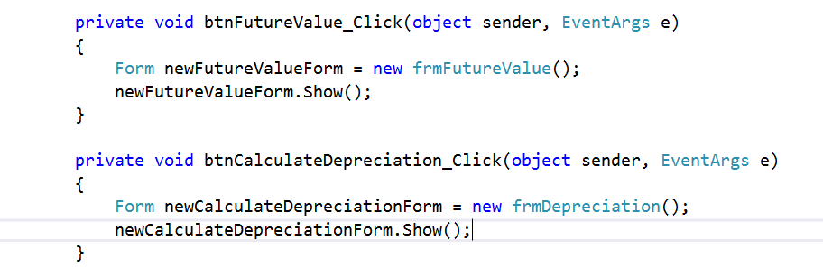

7. 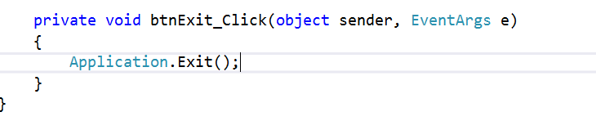

8. 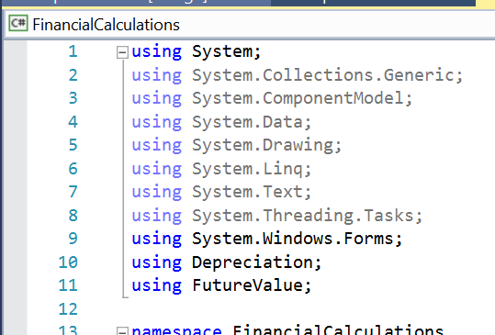

Here I used the using directive along with namespaces to get the program to work.

9. 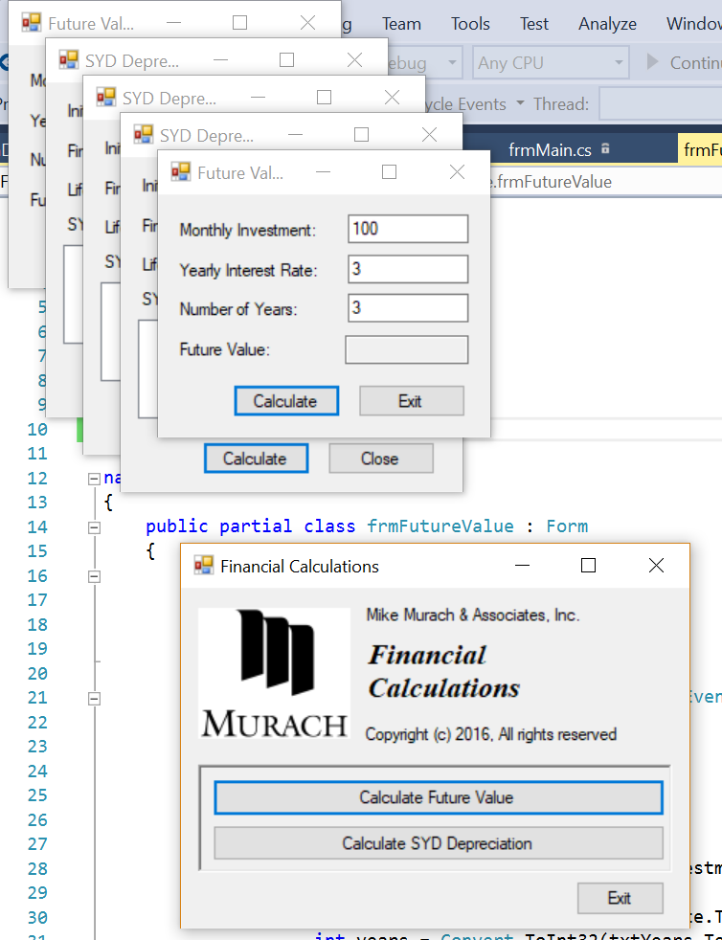

10. 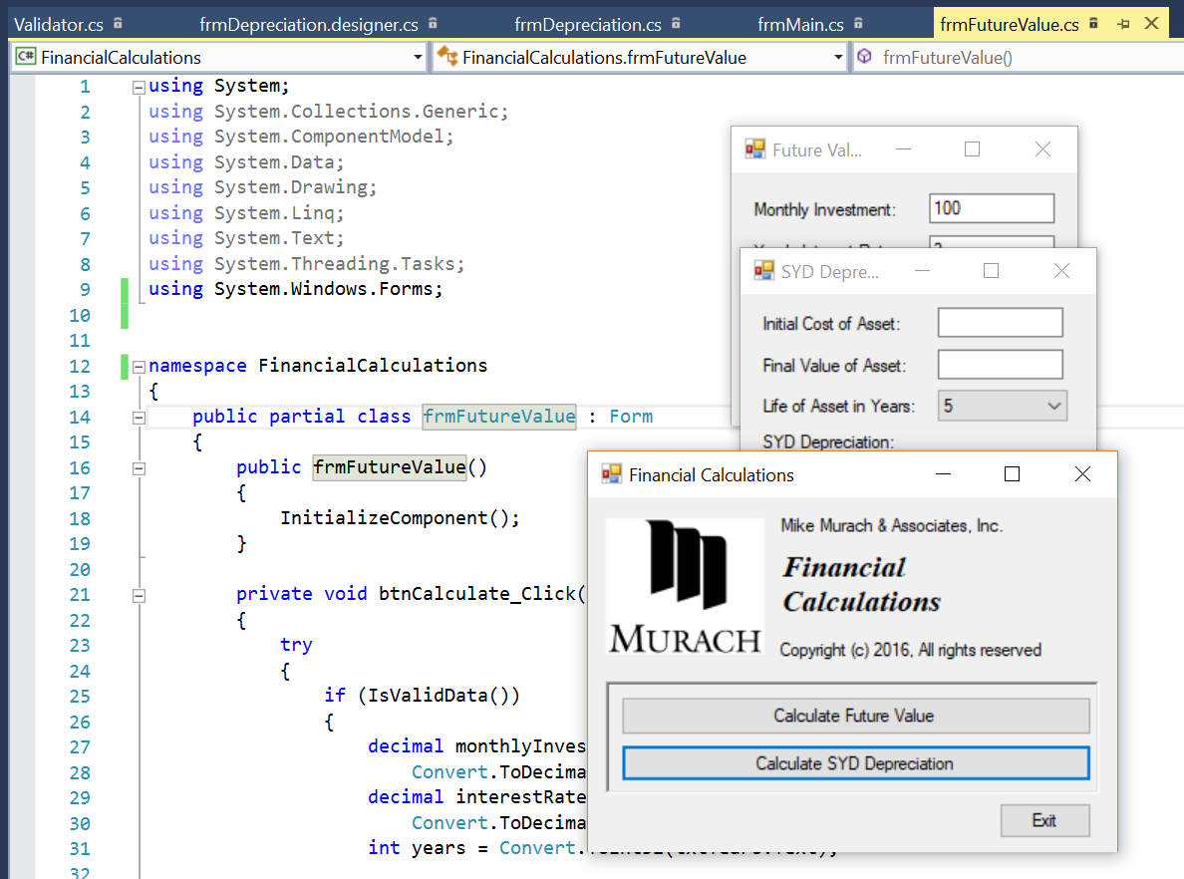

You can see I am inside of the futureValueForm and the namespace has been changed to FinancialCalculations and is working.